Algorithms – Data Structures
Exercise 1: Inventory Management System

Understanding the Problem and Data Structures and Algorithms Importance
In a warehouse inventory system, there may be thousands or millions of products.
Data Structures help:
- Store products efficiently.
- Retrieve product details quickly.
- Update stock information easily.
- Delete discontinued products efficiently.
Algorithms help:
- Search products quickly.
- Sort products based on price, quantity, etc.
- Manage inventory operations efficiently.
Without proper data structures and algorithms, operations become slow as the inventory grows.

Suitable Data Structures
Data Structure | Advantages | Disadvantages
ArrayList | Easy to use, dynamic size | Searching is O(n)
LinkedList | Fast insertion/deletion | Slow searching
HashMap | Fast add, search, update, delete | More memory usage

Best Choice: HashMap
Setup
Product.java
class Product {
int productId;
String productName;
int quantity;
double price;
Product(int productId, String productName, int quantity, double price) {
this.productId = productId;
this.productName = productName;
this.quantity = quantity;
this.price = price;
}
public String toString() {
return "ID: " + productId +
", Name: " + productName +
", Quantity: " + quantity +
", Price: ₹" + price;
}
}

InventoryManagement.java
import java.util.HashMap;
class InventoryManagement {
HashMap<Integer, Product> inventory = new HashMap<>();
void addProduct(Product p) {
inventory.put(p.productId, p);
System.out.println("Product Added.");
}
void updateProduct(int id, int quantity, double price) {
Product p = inventory.get(id);
if (p != null) {
p.quantity = quantity;
p.price = price;
System.out.println("Product Updated.");
} else {
System.out.println("Product Not Found.");
}
}
void deleteProduct(int id) {
if (inventory.remove(id) != null) {
System.out.println("Product Deleted.");
} else {
System.out.println("Product Not Found.");
}
}
void displayProducts() {
for (Product p : inventory.values()) {
System.out.println(p);
}
}
}

Main.java
public class Main {
public static void main(String[] args) {
InventoryManagement ims = new InventoryManagement();
Product p1 = new Product(101, "Laptop", 20, 50000);
Product p2 = new Product(102, "Mouse", 100, 500);
Product p3 = new Product(103, "Keyboard", 50, 1200);
ims.addProduct(p1);
ims.addProduct(p2);
ims.addProduct(p3);
System.out.println("\nInventory:");
ims.displayProducts();
System.out.println("\nUpdating Product 102...");
ims.updateProduct(102, 120, 550);
System.out.println("\nDeleting Product 103...");
ims.deleteProduct(103);
System.out.println("\nFinal Inventory:");
ims.displayProducts();
}
}

Output:
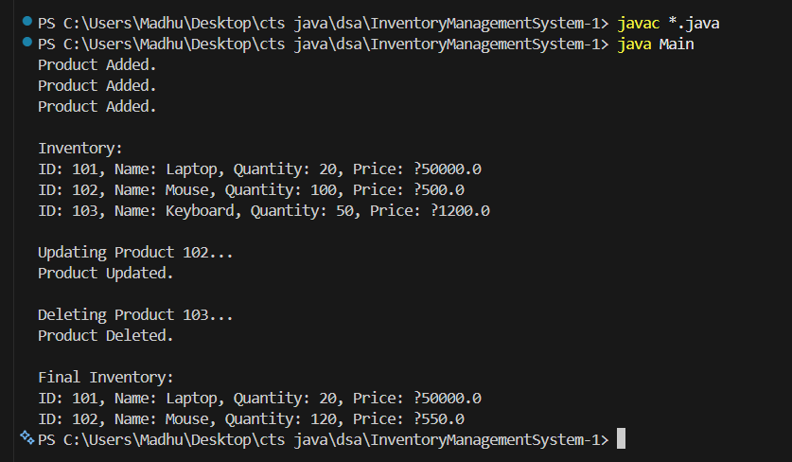
4. Analysis: Time Complexity using HashMap
Operation | Method Used | Time Complexity
Add Product | put() | O(1)
Search Product | get() | O(1)
Update Product | get() + update | O(1)
Delete Product | remove() | O(1)
Display Products | Traversal | O(n)
Where n = number of products.

Optimization

1. Use HashMap.
2. Unique Product Id
3. Store Frequently Accessed Data
4. Use Database for Very Large Inventories

Exercise 2: E-commerce Platform Search Function

Understanding Asymptotic Notation

Big O Notation:
Big O Notation is used to measure the efficiency of an algorithm as the input size increases.
It describes how the running time grows with the number of elements (n).

Examples
Complexity | Meaning
O(1) | Constant Time
O(log n) | Logarithmic Time
O(n) | Linear Time
O(n²) | Quadratic Time

Why is Big O Important?
- Helps compare algorithms.
- Predicts performance for large datasets.
- Helps choose the most efficient solution.
For an e-commerce platform with thousands of products, choosing an efficient search algorithm is very important.

Search Operation Cases

Best Case
Element found at the first position.
Product found immediately.
Time Complexity:
O(1)

Average Case
Element found somewhere in the middle.
Time Complexity:
O(n)
for Linear Search.
O(log n)
for Binary Search.

Worst Case
Element is:
- At the last position
- Or not present
Time Complexity:
Linear Search → O(n)

Binary Search → O(log n)

Setup:
Product.java
class Product {

int productId;
String productName;
String category;

Product(int productId, String productName, String category) {
this.productId = productId;
this.productName = productName;
this.category = category;
}

public String toString() {
return productId + " " + productName + " " + category;
}
}

Implementation

SearchDemo.java
public class SearchDemo {

// Linear Search
static Product linearSearch(Product[] products, int targetId) {

for (Product p : products) {
if (p.productId == targetId) {
return p;
}
}

return null;
}

// Binary Search
static Product binarySearch(Product[] products, int targetId) {

int left = 0;
int right = products.length - 1;

while (left <= right) {

int mid = (left + right) / 2;

if (products[mid].productId == targetId)
return products[mid];

else if (products[mid].productId < targetId)
left = mid + 1;

else
right = mid - 1;
}

return null;
}

public static void main(String[] args) {

Product[] products = {
new Product(101, "Laptop", "Electronics"),
new Product(102, "Mouse", "Electronics"),
new Product(103, "Keyboard", "Electronics"),
new Product(104, "Headphones", "Electronics"),
new Product(105, "Monitor", "Electronics")
};

int searchId = 104;

Product result1 = linearSearch(products, searchId);

if (result1 != null)
System.out.println("Linear Search Found: " + result1);
else
System.out.println("Product Not Found");

Product result2 = binarySearch(products, searchId);

if (result2 != null)
System.out.println("Binary Search Found: " + result2);
else
System.out.println("Product Not Found");
}
}
Output:

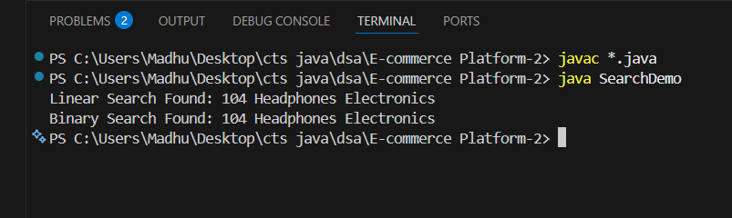

Working of Linear Search
Suppose we search:
104
Array:
101 102 103 104 105
Checks:
101 -No
102 - No
103 - No
104 -Yes
Elements checked = 4

Working of Binary Search
Array must be sorted.
101 102 103 104 105
Search:
104
Steps:
Mid = 103
104 > 103
Move Right

104 found
Only 2 comparisons needed.

4. Analysis

Time Complexity Comparison
Operation | Linear Search | Binary Search
Best Case | O(1) | O(1)
Average Case | O(n) | O(log n)
Worst Case | O(n) | O(log n)

Example with 1,000,000 Products

Linear Search
May check:
1,000,000 products
Complexity:
O(n)

Binary Search
Checks approximately:
log₂(1,000,000)
≈ 20 comparisons
Complexity:
O(log n)
Much faster.

Which Algorithm is Better?

Linear Search
Advantages:
- Simple implementation.
- Works on unsorted data.
Disadvantages:
- Slow for large datasets.

Binary Search
Advantages:
- Very fast.
- Suitable for large product catalogs.
Disadvantages:
- Requires sorted data.
For an E-commerce Platform, Binary Search is the better choice .

Exercise 3: Sorting Customer Orders

1. Understanding Sorting Algorithms
Sorting means arranging data in a particular order (ascending or descending).
In an e-commerce platform, sorting orders by totalPrice helps identify high-value orders quickly.

Bubble Sort

Working
- Compare adjacent elements.
- Swap if they are in the wrong order.
- Repeat until the array is sorted.
Example:
5000 3000 7000

5000 > 3000 → Swap

3000 5000 7000

Time Complexity
Case | Complexity
Best | O(n)
Average | O(n²)
Worst | O(n²)

Insertion Sort

Working
- Assume first element is sorted.
- Insert each new element into its correct position.
Example:
5 3 4

5

3 5

3 4 5

Time Complexity
Case | Complexity
Best | O(n)
Average | O(n²)
Worst | O(n²)

Quick Sort

Working
- Select a pivot element.
- Place smaller elements on the left.
- Place larger elements on the right.
- Recursively sort both parts.
Example:
50 30 70 20 60

Pivot = 50

20 30 | 50 | 60 70

Time Complexity
Case | Complexity
Best | O(n log n)
Average | O(n log n)
Worst | O(n²)

Merge Sort

Working
- Divide array into halves.
- Sort each half.
- Merge them.
Example:
8 3 6 2

8 3 | 6 2

3 8 | 2 6

2 3 6 8

Time Complexity
Case | Complexity
Best | O(n log n)
Average | O(n log n)
Worst | O(n log n)
Setup

Order.java
class Order {

int orderId;
String customerName;
double totalPrice;

Order(int orderId, String customerName, double totalPrice) {
this.orderId = orderId;
this.customerName = customerName;
this.totalPrice = totalPrice;
}

public String toString() {
return "Order ID: " + orderId +
", Customer: " + customerName +
", Total Price: ₹" + totalPrice;
}
}

Implementation

SortingOrders.java
public class SortingOrders {

// Bubble Sort
static void bubbleSort(Order[] orders) {

int n = orders.length;

for (int i = 0; i < n - 1; i++) {

for (int j = 0; j < n - i - 1; j++) {

if (orders[j].totalPrice > orders[j + 1].totalPrice) {

Order temp = orders[j];
orders[j] = orders[j + 1];
orders[j + 1] = temp;
}
}
}
}

// Quick Sort
static void quickSort(Order[] orders, int low, int high) {

if (low < high) {

int pi = partition(orders, low, high);

quickSort(orders, low, pi - 1);
quickSort(orders, pi + 1, high);
}
}

static int partition(Order[] orders, int low, int high) {

double pivot = orders[high].totalPrice;

int i = low - 1;

for (int j = low; j < high; j++) {

if (orders[j].totalPrice < pivot) {

i++;

Order temp = orders[i];
orders[i] = orders[j];
orders[j] = temp;
}
}

Order temp = orders[i + 1];
orders[i + 1] = orders[high];
orders[high] = temp;

return i + 1;
}

static void display(Order[] orders) {

for (Order o : orders) {
System.out.println(o);
}
}

public static void main(String[] args) {

Order[] orders1 = {
new Order(101, "Rahul", 5000),
new Order(102, "Priya", 2000),
new Order(103, "Arun", 8000),
new Order(104, "Meena", 3000)
};

System.out.println("Before Bubble Sort:");
display(orders1);

bubbleSort(orders1);

System.out.println("\nAfter Bubble Sort:");
display(orders1);

Order[] orders2 = {
new Order(101, "Rahul", 5000),
new Order(102, "Priya", 2000),
new Order(103, "Arun", 8000),
new Order(104, "Meena", 3000)
};

quickSort(orders2, 0, orders2.length - 1);

System.out.println("\nAfter Quick Sort:");
display(orders2);
}
}
Output:
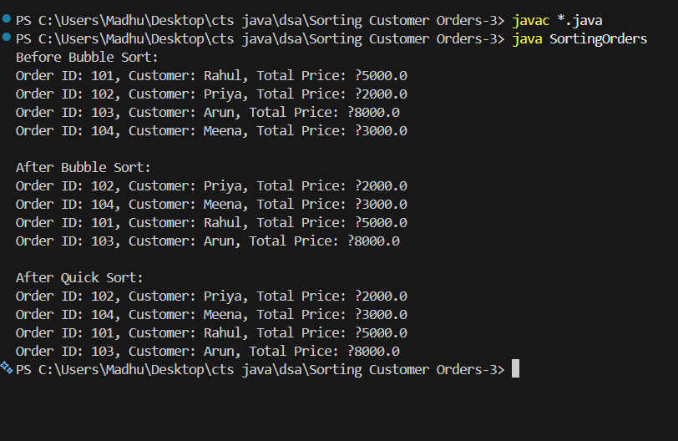

Analysis

Time Complexity Comparison
Case | Bubble Sort | Quick Sort
Best Case | O(n) | O(n log n)
Average Case | O(n²) | O(n log n)
Worst Case | O(n²) | O(n²)

Why Quick Sort is Preferred?

Bubble Sort
Too many comparisons
Slow for large datasets
Not suitable for e-commerce platforms

Quick Sort
Fast average performance
O(n log n) complexity
Handles large order data efficiently
Widely used in real-world applications
Preferred Algorithm
✔ Quick Sort

Exercise 4: Employee Management System

Understanding Array Representation

Arrays are Represented As
An array stores elements in contiguous (continuous) memory locations.
Example:
Index: 0 1 2 3
Array: Emp1 Emp2 Emp3 Emp4
Memory Representation:
1000 1004 1008 1012
Emp1 Emp2 Emp3 Emp4
Each element occupies consecutive memory locations.

Advantages of Arrays

1. Fast Access

2. Easy Traversal

3. Less Memory Overhead

2. Setup

Employee.java
class Employee {

int employeeId;
String name;
String position;
double salary;

Employee(int employeeId, String name,
String position, double salary) {

this.employeeId = employeeId;
this.name = name;
this.position = position;
this.salary = salary;
}

public String toString() {
return "ID: " + employeeId +
", Name: " + name +
", Position: " + position +
", Salary: ₹" + salary;
}
}

3. Implementation

EmployeeManagement.java
class EmployeeManagement {

Employee[] employees;
int count;

EmployeeManagement(int size) {
employees = new Employee[size];
count = 0;
}

// Add Employee
void addEmployee(Employee e) {

if (count < employees.length) {
employees[count] = e;
count++;
System.out.println("Employee Added");
} else {
System.out.println("Array Full");
}
}

// Search Employee
Employee searchEmployee(int id) {

for (int i = 0; i < count; i++) {

if (employees[i].employeeId == id) {
return employees[i];
}
}

return null;
}

// Traverse Employees
void traverseEmployees() {

for (int i = 0; i < count; i++) {
System.out.println(employees[i]);
}
}

// Delete Employee
void deleteEmployee(int id) {

int index = -1;

for (int i = 0; i < count; i++) {

if (employees[i].employeeId == id) {
index = i;
break;
}
}

if (index == -1) {
System.out.println("Employee Not Found");
return;
}

for (int i = index; i < count - 1; i++) {
employees[i] = employees[i + 1];
}

employees[count - 1] = null;
count--;

System.out.println("Employee Deleted");
}
}

Main.java
public class Main {

public static void main(String[] args) {

EmployeeManagement em =
new EmployeeManagement(10);

em.addEmployee(
new Employee(101,
"Rahul",
"Manager",
60000));

em.addEmployee(
new Employee(102,
"Priya",
"Developer",
50000));

em.addEmployee(
new Employee(103,
"Arun",
"Tester",
40000));

System.out.println("\nEmployee Records:");

em.traverseEmployees();

System.out.println("\nSearching Employee 102:");

Employee e =
em.searchEmployee(102);

if (e != null)
System.out.println(e);
else
System.out.println("Not Found");

System.out.println("\nDeleting Employee 102");

em.deleteEmployee(102);

System.out.println("\nUpdated Records:");

em.traverseEmployees();
}
}
Output:
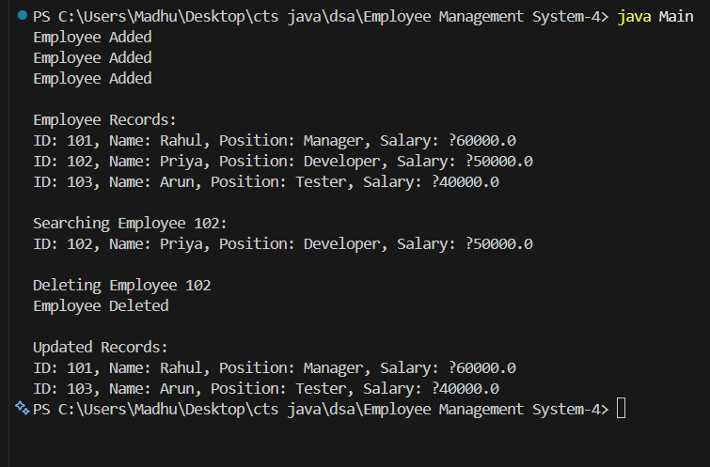

Analysis

Time Complexity
Operation | Complexity
Add Employee | O(1)
Search Employee | O(n)
Traverse Employees | O(n)
Delete Employee | O(n)
Where n = number of employees.

Add Operation
employees[count] = e;
Direct insertion at the end.
Time Complexity = O(1)

Search Operation
for(...)
May need to check every employee.
Best Case = O(1)
Worst Case = O(n)

Traverse Operation
Visits all employees.
O(n)

Delete Operation
After finding the employee, remaining elements must be shifted.
O(n)
Limitations of Arrays:
- Arrays have a fixed size and cannot be resized easily after creation.
- Insertion and deletion operations are time-consuming because elements need to be shifted.
- Memory may be wasted if the allocated array size is larger than the actual data stored.

When to Use Arrays?

Use arrays when:
Number of records is known in advance
Fast index-based access is required
Memory efficiency is important
Data size is small or fixed
- Examples: Student records

Exercise 5: Task Management System

1. Understanding Linked Lists
A Linked List is a linear data structure where elements (nodes) are connected using pointers
Each node contains:
- Data
- Reference to the next node

Singly Linked List
Each node points to the next node.
Task1 → Task2 → Task3 → NULL

Features
Less memory than doubly linked list
Easy insertion and deletion
Can only traverse forward

Doubly Linked List
Each node contains:
- Previous pointer
- Next pointer
NULL ← Task1 ⇄ Task2 ⇄ Task3 → NULL

Features
Forward traversal
Backward traversal
Easier deletion
Extra memory needed for previous pointer

2. Setup

Task.java
class Task {

int taskId;
String taskName;
String status;

Task(int taskId, String taskName, String status) {
this.taskId = taskId;
this.taskName = taskName;
this.status = status;
}
}

3. Implementation

TaskNode.java
class TaskNode {

Task task;
TaskNode next;

TaskNode(Task task) {
this.task = task;
this.next = null;
}
}

TaskManagement.java
class TaskManagement {

TaskNode head = null;

// Add Task
void addTask(Task task) {

TaskNode newNode = new TaskNode(task);

if (head == null) {
head = newNode;
return;
}

TaskNode temp = head;

while (temp.next != null) {
temp = temp.next;
}

temp.next = newNode;
}

// Search Task
Task searchTask(int id) {

TaskNode temp = head;

while (temp != null) {

if (temp.task.taskId == id) {
return temp.task;
}

temp = temp.next;
}

return null;
}

// Traverse Tasks
void traverseTasks() {

TaskNode temp = head;

while (temp != null) {

System.out.println(
"Task ID: " + temp.task.taskId +
", Name: " + temp.task.taskName +
", Status: " + temp.task.status
);

temp = temp.next;
}
}

// Delete Task
void deleteTask(int id) {

if (head == null)
return;

if (head.task.taskId == id) {
head = head.next;
System.out.println("Task Deleted");
return;
}

TaskNode temp = head;

while (temp.next != null &&
temp.next.task.taskId != id) {

temp = temp.next;
}

if (temp.next == null) {
System.out.println("Task Not Found");
return;
}

temp.next = temp.next.next;

System.out.println("Task Deleted");
}
}

Main.java
public class Main {

public static void main(String[] args) {

TaskManagement tm = new TaskManagement();

tm.addTask(
new Task(101,
"Design UI",
"Pending"));

tm.addTask(
new Task(102,
"Develop Backend",
"In Progress"));

tm.addTask(
new Task(103,
"Testing",
"Pending"));

System.out.println("All Tasks:");

tm.traverseTasks();

System.out.println("\nSearching Task 102:");

Task t = tm.searchTask(102);

if (t != null) {

System.out.println(
"Task ID: " + t.taskId +
", Name: " + t.taskName +
", Status: " + t.status);
}
else {
System.out.println("Task Not Found");
}

System.out.println("\nDeleting Task 102");

tm.deleteTask(102);

System.out.println("\nRemaining Tasks:");

tm.traverseTasks();
}
}

Output:
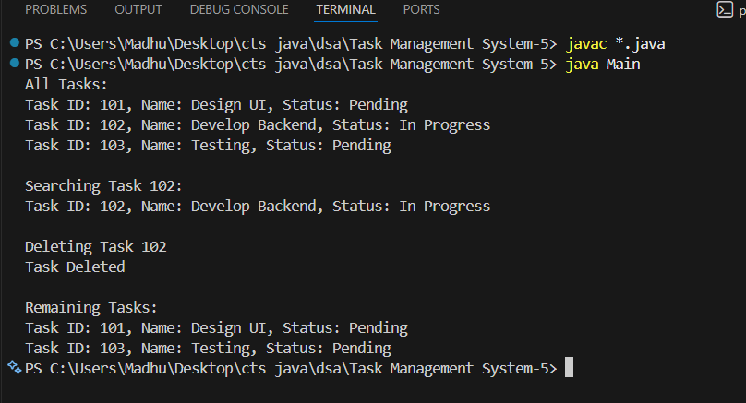4. Analysis

Time Complexity
Operation | Time Complexity
Add Task | O(n)
Search Task | O(n)
Traverse Tasks | O(n)
Delete Task | O(n)
Where n = number of tasks.

Add Task
while(temp.next != null)
Need to reach the last node.
O(n)

Search Task
May check all nodes.
Best Case : O(1)
Worst Case : O(n)

Traverse Task
Visits every node.
O(n)

Delete Task
Need to locate the node first.
O(n)

Advantages of Linked Lists Over Arrays
Linked List | Array
Dynamic size | Fixed size
Easy insertion/deletion | Requires shifting elements
No memory wastage | May waste unused space
Memory allocated as needed | Memory allocated in advance

Exercise 6: Library Management System

1. Understanding Search Algorithms
Searching is the process of finding a specific element in a collection of data.
In a Library Management System, users may search for books by title or author.

Linear Search

Working
- Start from the first element.
- Compare each element with the target.
- Stop when the element is found or the list ends.

Example
Books:
Java
Python
C++
Data Structures

Search: C++

Java -No
Python -No
C++ -Yes

Characteristics
Works on sorted and unsorted data
Easy to implement
Slow for large datasets

Binary Search

Working
- Works only on sorted data.
- Find the middle element.
- If target equals middle → found.
- If target is smaller → search left half.
- If target is larger → search right half.
- Repeat until found.

Example
Books:
C++
Data Structures
Java
Python

Search: Java

Middle = Data Structures

Java > Data Structures

Search Right Half

Middle = Java

Found

Characteristics
Very fast
Suitable for large datasets
Requires sorted data

2. Setup

Book.java
class Book {

int bookId;
String title;
String author;

Book(int bookId, String title, String author) {
this.bookId = bookId;
this.title = title;
this.author = author;
}

public String toString() {
return "Book ID: " + bookId +
", Title: " + title +
", Author: " + author;
}
}

3. Implementation

LibrarySearch.java
public class LibrarySearch {

// Linear Search by Title
static Book linearSearch(Book[] books, String targetTitle) {

for (Book book : books) {

if (book.title.equalsIgnoreCase(targetTitle)) {
return book;
}
}

return null;
}

// Binary Search by Title
static Book binarySearch(Book[] books, String targetTitle) {

int low = 0;
int high = books.length - 1;

while (low <= high) {

int mid = (low + high) / 2;

int compare =
books[mid].title.compareToIgnoreCase(targetTitle);

if (compare == 0)
return books[mid];

else if (compare < 0)
low = mid + 1;

else
high = mid - 1;
}

return null;
}

public static void main(String[] args) {

// Sorted by title
Book[] books = {

new Book(101,
"C++ Programming",
"Bjarne Stroustrup"),

new Book(102,
"Data Structures",
"Mark Allen Weiss"),

new Book(103,
"Java Programming",
"James Gosling"),

new Book(104,
"Python Basics",
"Guido van Rossum")
};

String searchTitle = "Java Programming";

System.out.println("Linear Search:");

Book result1 =
linearSearch(books, searchTitle);

if (result1 != null)
System.out.println(result1);
else
System.out.println("Book Not Found");

System.out.println("\nBinary Search:");

Book result2 =
binarySearch(books, searchTitle);

if (result2 != null)
System.out.println(result2);
else
System.out.println("Book Not Found");
}
}
Output:
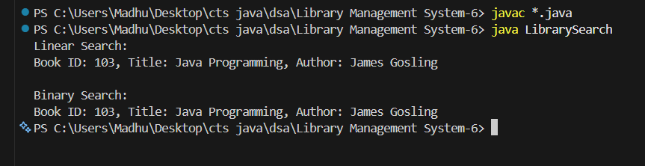
4. Analysis

Time Complexity Comparison
Case | Linear Search | Binary Search
Best Case | O(1) | O(1)
Average Case | O(n) | O(log n)
Worst Case | O(n) | O(log n)

When to Use Linear Search?
Use Linear Search when:
Data is unsorted
Dataset is small
Simplicity is preferred
Example:
10–50 books
Linear search is sufficient.

When to Use Binary Search?
Use Binary Search when:
Data is sorted
Dataset is very large
Fast searching is required
Example:
Thousands or millions of books
Binary search is the better choice.

Exercise 7: Financial Forecasting

Recursion:
Recursion is a programming technique where a method calls itself to solve a smaller version of the same problem.
A recursive function consists of:
- Base Case – Stops the recursion.
- Recursive Case – Calls itself with a smaller input.

Example: Factorial
int factorial(int n) {
if(n == 0)
return 1;

return n * factorial(n - 1);
}

Why Recursion Helps?
Recursion simplifies problems that can be broken into smaller subproblems.
Examples:
- Tree Traversal
- Binary Search
- Fibonacci Series
- Financial Forecasting

2. Setup
Suppose:
- Current Investment = ₹10,000
- Annual Growth Rate = 10%
- Forecast Period = 5 Years
Formula:
Future Value = Current Value × (1 + Growth Rate)
Recursive Relation:
FV(n) = FV(n-1) × (1 + rate)
Base Case:
FV(0) = Current Value

3. Implementation

FinancialForecast.java
public class FinancialForecast {

static double predictFutureValue(
double currentValue,
double growthRate,
int years) {

// Base Case
if (years == 0)
return currentValue;

// Recursive Case
return predictFutureValue(
currentValue,
growthRate,
years - 1)
* (1 + growthRate);
}

public static void main(String[] args) {

double currentValue = 10000;
double growthRate = 0.10; // 10%
int years = 5;

double futureValue =
predictFutureValue(
currentValue,
growthRate,
years);

System.out.printf(
"Future Value after %d years = ₹%.2f",
years,
futureValue);
}
}
Output:
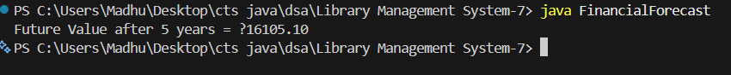

4. Analysis

Time Complexity
Let:
n = number of years
Each recursive call performs:
- One multiplication
- One recursive call
Therefore:
T(n) = T(n-1) + O(1)
Result:
Time Complexity = O(n)

Space Complexity
Because each recursive call is stored on the call stack:
Space Complexity = O(n)

Recursive Call Stack Example
predict(5)
predict(4)
predict(3)
predict(2)
predict(1)
predict(0)
Total stack frames: 6
Hence: O(n) space

Optimization

Problem with Some Recursive Solutions
Consider Fibonacci:
fib(n) = fib(n-1) + fib(n-2);
This recalculates values repeatedly.
Example:
fib(5)

fib(4)
fib(3)

fib(3) repeated
fib(2) repeated
This causes:
O(2^n)
complexity.

Optimization 1: Memoization
Store already calculated results.Reuse previous calculations instead of recomputing.

Optimization 2: Dynamic Programming
Build solutions from smaller results iteratively.
for(int i=1;i<=years;i++)
value *= (1 + growthRate);

Complexity:
Time = O(n)
Space = O(1)

Optimization 3: Direct Formula
Financial forecasting can be calculated directly using compound growth:
Future Value =
Current Value × (1 + Rate)^Years
Java:
double futureValue =
currentValue *
Math.pow(1 + growthRate, years);

Example: double fv =10000 * Math.pow(1.10, 5);
Complexity: Time Complexity ≈ O(log n)

